# **JAABA Instructions on Ohyama_Dell Desktop**

Already made classifiers are at ‘…\Documents\JAABA\Classifiers’

### Process data by JAABA

1. Load Matlab 2014a.
2. Make sure to copy data to folders : ‘…\Documents\choreography_inputs’ and ‘…\Documents\choreography_results’
3. Double click script_ProcessJAABA as followed.  
   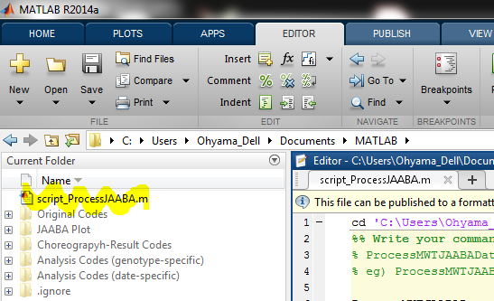
4. Write the commands as followed (fill in genotype and name of classifier), drag, right-click, and select **Evaluate Selection**.  
   *If multiple genotypes, drag multiple command lines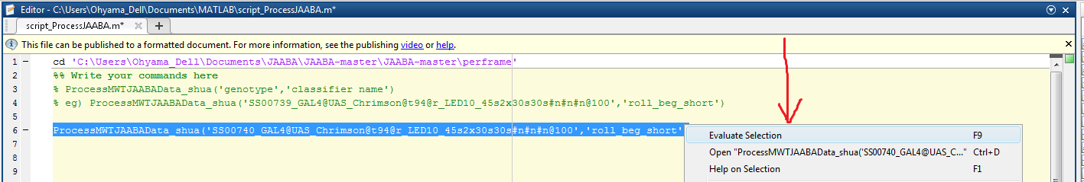
5. Output will be created under ‘…\Documents\JAABA_processed’  
   *One timestamp approximately takes 5 minutes  
   \***scores_((classifier name))_update.mat**:

|  |  |
| --- | --- |
| scores | If value<0, NOT a behavior  If value>0, IS a behavior |
| tStart, tEnd | Frames where tracking starts, ends |
| postprocessed | If value=0, NOT a behavior  If value=1, IS a behavior |
| t0s,t1s | Frames where behavior starts, ends |
| timestamps | Seconds at each timeframe |
| t0sProcessed, t1sProcessed | Currently,   1. <=4 frames gaps are combined 2. <=3 frames duration behavior are erased   You can change the threshold in ‘…\Documents\JAABA\JAABA-master\JAABA-master\perframe\PostProcessJAABA_shua.m’ |
| T0sSeconds, t1sSeconds | t0sProcessed, t1sProcessed converted to seconds |
| tStartSeconds, tEndSeconds | tStart, tEnd converted to seconds |

### Turning JAABA data into ‘((genotype)).crabspeed_area-animal_stats_rolls_JAABA.txt’ (same as files created after running feature extraction)

1. Load Matlab 2019a.
2. Double click script_JAABA_makeanimalstat as followed.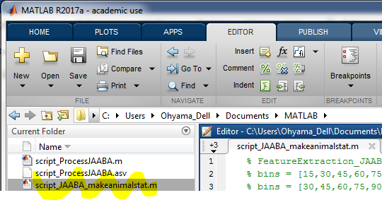
3. Write the commands (fill in genotype and time bins), drag, right-click, and select **Evaluate Selection**.  
   *If multiple genotypes, drag multiple command lines
4. Output will be created under ‘…\Documents\feature_extraction’  
   *Takes a short time  
   \***((genotype)).crabspeed_area-animal_stats_rolls_JAABA.txt** is created inside each timestamp and outside timestamps (all combined)

### Creating Classifier Using JAABA

1. Load Matlab 2014a.
2. Double click script_maketrx.m at Matlab 2014a
3. Write the commands (fill in genotype), drag, right-click, and select **Evaluate Selection**.  
   *If multiple genotypes, drag multiple command lines  
   *One timestamp approximately takes 3 minutes
4. Go to ‘…\Documents\JAABA\JAABA-master\JAABA-master\perframe’ at Matlab 2014a by double clicking directories
5. At LiveScript, write run StartJAABA
6. Further guide is at <http://jaaba.sourceforge.net/>